1. Packages

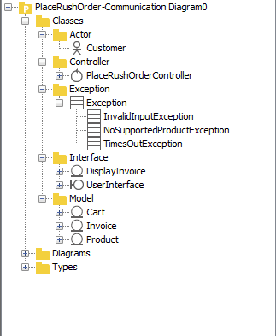

1. Class diagram

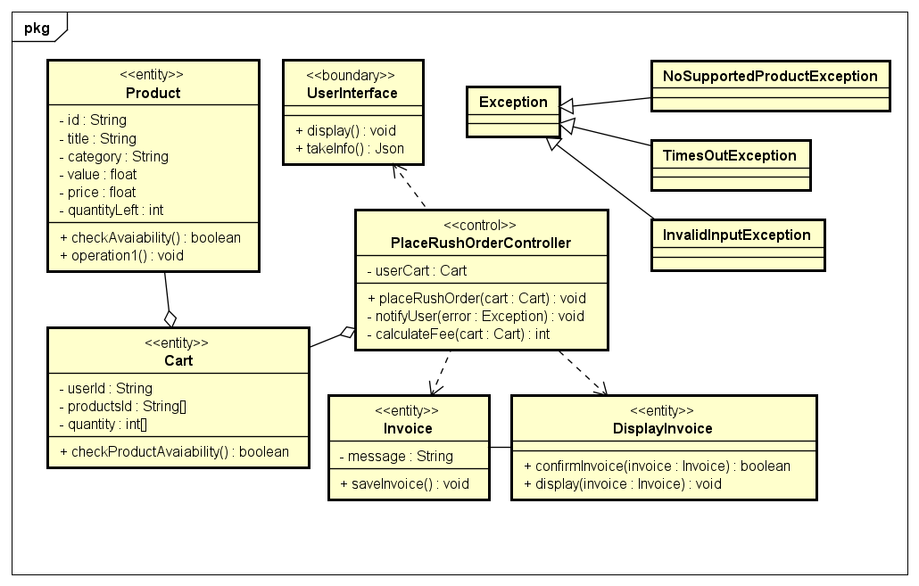

1. Class specification
2. Class Product

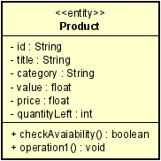

***Attributes:***

|  |  |  |  |  |
| --- | --- | --- | --- | --- |
| # | Name | Data Type | Default value | Description |
| 1 | id | String | Null | // |
| 2 | title | String | Null | // |
| 3 | category | String | Null | // |
| 4 | value | Float | Null | // |
| 5 | price | float | null | // |
| 6 | quantityLeft | int | Null | Number of product left |

***Operations:***

|  |  |  |  |  |  |
| --- | --- | --- | --- | --- | --- |
| # | Name | Return Type | Description | Parameter | Exception |
| 1 | checkAvaiability | booean | Check wheather this product quantityLeft >0 | null | null |

***Method:***

None

***State:***

None

1. Class Cart

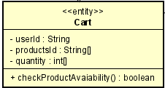

***Attributes:***

|  |  |  |  |  |
| --- | --- | --- | --- | --- |
| # | Name | Data Type | Default value | Description |
| 1 | userId | String | Null | Ower user id |
| 2 | productsId | String[] | Null | The products in the cart |
| 3 | category | String | Null | // |
| 4 | value | Float | Null | // |
| 5 | price | float | null | // |
| 6 | quantity | Int[] | Null | Number of product putted in the cart corresponding with the productId |

***Operations:***

|  |  |  |  |  |  |
| --- | --- | --- | --- | --- | --- |
| # | Name | Return Type | Description | Parameter | Exception |
| 1 | checkAvaiability | booean | Check wheather each product in the cart is available | null | null |

***Method:***

None

***State:***

None

1. Class Invoice

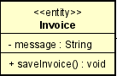

***Attributes:***

|  |  |  |  |  |
| --- | --- | --- | --- | --- |
| # | Name | Data Type | Default value | Description |
| 1 | message | String | null | fee, products supported,… |

***Operations:***

|  |  |  |  |  |  |
| --- | --- | --- | --- | --- | --- |
| # | Name | Return Type | Description | Parameter | Exception |
| 1 | saveInvoice | null | Save this invoice | null | null |

***Method:***

None

***State:***

None

1. Class DisplayInvoice

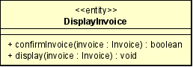

***Attributes:***

|  |  |  |  |  |
| --- | --- | --- | --- | --- |
| # | Name | Data Type | Default value | Description |

***Operations:***

|  |  |  |  |  |  |
| --- | --- | --- | --- | --- | --- |
| # | Name | Return Type | Description | Parameter | Exception |
| 1 | confirmInvoice | booean | Return if the user accept the fee | Invoice – containing the info f the rush order | TimesOutException- if the user take too long to respond |
| 2 | display | null | Display the invoice | Invoice – containg …. | null |

***Method:***

None

***State:***

None

1. Class UserInterface (nothing much to do, since it using same interface of Place Order use case, the following is the simple version of the interface in the Place Order use case)

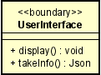

***Attributes:***

|  |  |  |  |  |
| --- | --- | --- | --- | --- |
| # | Name | Data Type | Default value | Description |

***Operations:***

|  |  |  |  |  |  |
| --- | --- | --- | --- | --- | --- |
| # | Name | Return Type | Description | Parameter | Exception |
| 1 | display | void | Display the interface | null | null |
| 2 | takeInfo | Json | Take the info the user inputs | null | InvalidInputException-If the user input is invalid  TimesOutException- if the user take too long to respond |

***Method:***

None

***State:***

None

1. Class PlaceRushOrderController

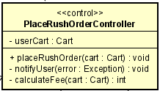

***Attributes:***

|  |  |  |  |  |
| --- | --- | --- | --- | --- |
| # | Name | Data Type | Default value | Description |
| 1 | userCart | Cart | null | // |

***Operations:***

|  |  |  |  |  |  |
| --- | --- | --- | --- | --- | --- |
| # | Name | Return Type | Description | Parameter | Exception |
| 1 | placeRushOrder | void | Start the place Rush Order process | Cart | NoSupportedProductExcetion – if no product in the cart is supported |

***Method:***

|  |  |  |  |  |  |
| --- | --- | --- | --- | --- | --- |
| # | Name | Return Type | Description | Parameter | Exception |
| 1 | calculateFee | int | Calculating the place rush order fee | cart | null |
| 2 | notifyUser | void | Notify User if an error occur | error | null |

***State:***

None